**ASSIGNMENT-2**

Create a New Facebook Business Page and Post one social media poster for your brand.

|  |  |
| --- | --- |
| NAME | S.SASIKUMAR |
| NM ID | E743439B51D3AC28ED844AA6B74B483E |
| ASSIGNMENT 2 | Create a New Facebook Business Page and Post one social media poster for your brand |

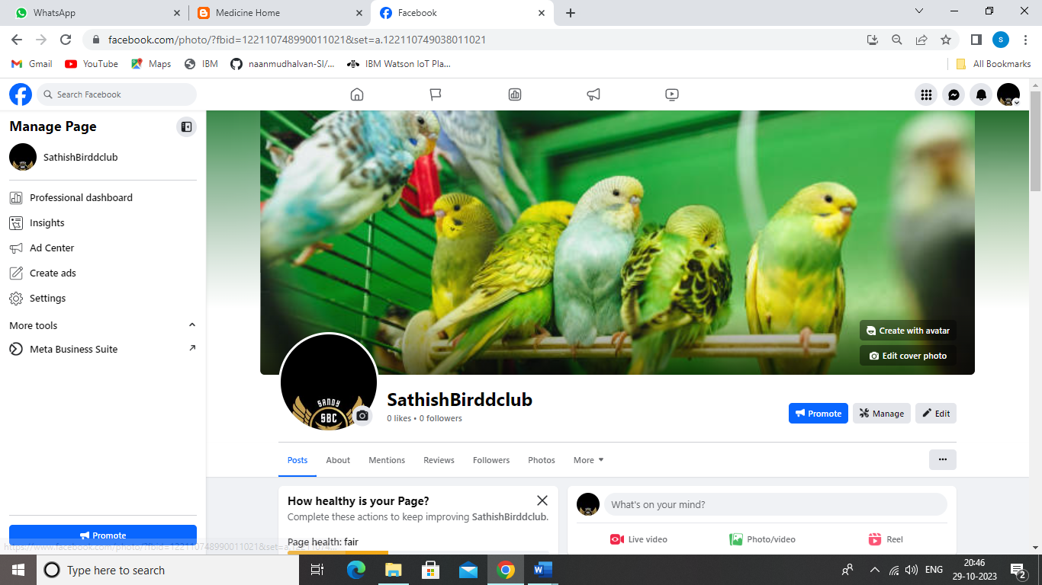

**FACEBOOK PAGE LINK:**

<https://www.facebook.com/sathishbirdclub>